**STA 141A HW#4**Hiu Man(Stephanie) Lam

ID: 913358632

**Honor code:**

The analysis derived by using the codes attached in appendix constitutes my own work. I have consulted the following resources regarding this assignment:

Ryan Kuan, Meixin Deng, Qiwen Guan, and Chloe Chen.

**Write up:**

The car data includes the information of 1531 advertisements of used vehicles. The data frame that I extracted consists of 14 columns, including Year, Make, Model, Vehicle Identification Number (VIN), Price, Mileage, Interior color, Exterior color, Transmission, Engine displacement (in liters), Name of company selling the car, Street address of the company, Phone number of the company, and the Website of the company. By doing a statistical summary, I found that the most car that were trying to sell are from 2012 and most of them are from the brand Nissan, followed by Ford and Toyota. The company “Maximum Auto Search” has the largest number of car advertisements, for 120 in total. On the other hand, most cars’ transmissions are automatic and have the color black for both interior and exterior. It is also important to note that by looking at the summary, there are some advertisements with the same VIN number, which means that some advertisements were posted more than once.

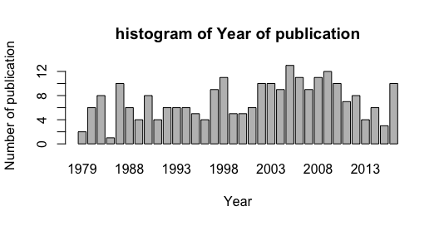

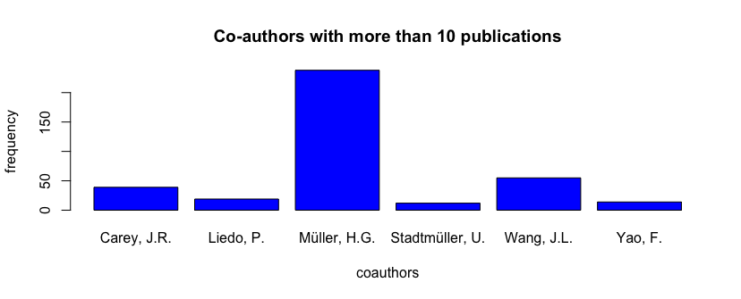

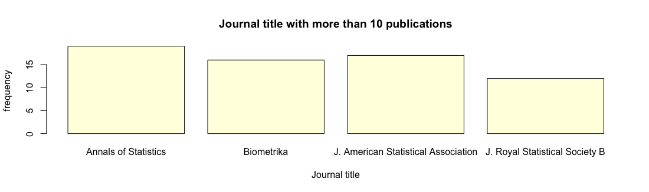

By extracting the data from the webpage that has a list of publications by Professor Hans-Gerog Muller using the xml2 package, I created a data frame that has the information of Year of publication, Authors, Title of publication, Journal title, Journal volume, and URL of the publication. I did a statistical summary of the result and found that Professor Muller had 13 publications in 2005 while 1986 had just 1 publication by looking at the graphs above. And he published 21 journals with the journal *Annals of Statistics*, which is the largest number of all. On the side note, the author Wang, J.L. appeared 55 times, which means that this author partnered with Professor Muller the most.